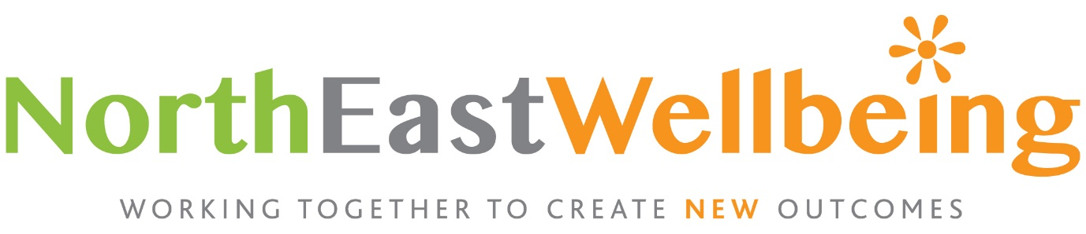

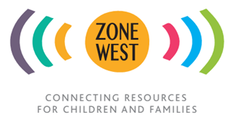
Zone West Link Worker
Appointment Brief
January 2022
Who we are.
Zone West is an early intervention project for children and young people, a collaboration between health, education and the community resources of West Newcastle. We work to place identified children at the centre of multi-source preventative support, working for long-term transformations. Zone West is a project managed by North East Wellbeing (reg charity no: 1154255)
Our Inspiration
We are inspired by the Harlem Children’s Zone, the West London Zone and the people, workers and resources of West Newcastle.

North East Wellbeing’s purpose is to create NEW landscapes of life chances for vulnerable children through colourful and creative education.

Our Vision
Zone West’s vision is of vulnerable children flourishing at the centre of integrated care to become positive influencers and drive change.

Our Strategy

Primary Schools in the West End of Newcastle serve a multi-cultural population and face multiple problems These include increasing levels of poverty, poor nutrition, and mental and emotional problems. All of these impact on health and learning outcomes and there is increasingly robust long-term evidence that indicates that being behind in primary school has an adverse impact on employment, income and health in adult life. In addition, there are increasing numbers of children who have educational special needs and/or mental health problems who do not meet the assessment criteria for service provision. This group require early intervention and support in order to build on existing strengths and flourish.
Zone West works with schools, local GP practices and voluntary sector organisations in order to develop a systematic approach to identifying and supporting these children and their parents. Once they have been identified, Link Workers engage with them and their families in order to provide a personalised package of local support. Zone West works with local activity and support providers in order to develop a menu of activities that can be accessed to provide personalised support plans. We are data-led and evidence-based, with Link Workers spending time gathering data to test and evaluate this approach with the intention of producing a model that can be scaled and spread.
In short, our strategy is to use stakeholders’ knowledge of the West End of Newcastle, the people, the community and its assets to create packages of care that change the lives of children. We believe we can best achieve this change by placing the child at the centre of the picture, orientating services around them by linking them to an independent worker who will be responsible for child outcomes.
Responsibilities.

Identifying and supporting children and families

- Act as a trusted adult and role model in the lives of the children, young people and families.
- Provide support to children, young people, families and carers to take control of their health and wellbeing, live independently and improve their health outcomes, as a key member of the PCN multi-disciplinary team.
- Maintain professional practice standards as outlined in legislation, guidance and consistent with ZONE WEST policies and procedures, particularly in relation to safeguarding
- Ensure that school data is collected, the ZONE WEST wellbeing survey is completed and consent for participation in ZONE WEST support is obtained from all families
- Develop personalised engagement plans in partnership with family members and professionals in schools, in order to determine the strengths, needs, and goals in the lives of the children and young people, and the necessary support to achieve them
- Encourage children to sustain their support, constantly developing innovative ideas to achieve this

Co-ordinating support from the social sector and promoting engagement in Schools

- Build relationships across staff in schools and social sector partners based on the young person’s priorities and the wider determinants of health, educational success and mental wellbeing.
- Co-ordinate seamless delivery of support by social sector partners both during and after the school day to help ZONE WEST partners to achieve their stated outcomes for the children, young people and families
- Draw on and increase the strengths and capacities of local communities, enabling local VCSE partner organisations and community groups to receive social prescribing referrals.
- Monitor progress throughout regarding strengths, needs, progress and goals and ensure transparent sharing of information between ZONE WEST, schools and partners.

Managing data and reporting

- Ensure that measurement data is adequately collected in all social sector partners’ pre and post measurement support sessions to provide evidence of services delivered and progress to outcomes
- Convey data transparently when necessary according to confidentiality agreements between the PCN, social sector partners, schools and ZONE WEST
- Maintain detailed notes, including instances of engagement, and gather relevant data on children, young people and families to evaluate situations and develop responses to complex problems
- Work closely within the MDT and with GP practices within the PCN to ensure that the social prescribing referral codes are inputted into clinical systems (as outlined in the Network Contract DES), adhering to data protection legislation and data sharing agreements.

Wider network building

- Promote social prescribing, its role in self-management, and the wider determinants of health.
- Establish links with key workers from local agencies and organisations also working with the families ZONE WEST is supporting, to ensure that ZONE WEST support is aligned with statutory support, particularly family practitioners, social workers and health visitors
- Accept a role in educating colleagues within the PCN multi-disciplinary teams on the mechanisms of social prescribing as experienced in delivering ZW outcomes. This may include verbal or written advice and guidance.
- Represent ZONE WEST at local group meetings to forge positive relationships with other organisations.

Management and administration
- Attend regular ZONE WEST team meetings, Link Worker meetings, supervision meetings and half-termly meetings with the schools and social sector partners to discuss status of provision and the ZONE WEST model
- Take responsibility for developing and improving your own professional knowledge and skills, contribute to the development of ZONE WEST, its policies and procedures, support colleagues through co-working, mentoring or critical appraisal

Responsibilities of all North East Wellbeing Staff
● Comply with all relevant North East Wellbeing Safeguarding policies
● Maintain an awareness of health and safety and comply with ZONE WEST’s Health and Safety Procedures
● Comply with North East Wellbeing Diversity and Equality policies and practices
● Maintain and develop competence in the use of IT systems
• A flexible approach to work is essential. All ZONE WEST staff may sometimes be required to adapt their duties to take account of changes in work practices

Link Worker Person Specification
Essential
- Relevant experience, e.g. family support work, education, social work, youth work, mentoring, counselling or similar
- Experience and interest in supporting children, young people and families to flourish
- Ability to manage relationships across multiple settings with different people
- Excellent communication skills, able to communicate professionally and flexibly with a wide group of stakeholders
- Good understanding of safeguarding in relation to children and young people
- Able to plan work and manage competing priorities in a busy, fast paced environment
- Fluent written and spoken English
- Good undergraduate degree or other equivalent qualification
- IT competence for producing data reports in a variety of formats (at a minimum, experience with Microsoft Office suite including Excel, Word, and Google Apps)

